**EE5904 Neural Networks: Homework 3**

**National University of Singapore**

**Zhang Fei A0117981x**

**Q1. Function Approximation with RBFN**

**a). Apply exact interpolation method**

**Source code**

1. **import** numpy as np
2. **import** matplotlib.pyplot as plt
4. x_train = np.arange(-1,1,0.05)
5. y_train = 1.2*np.sin(np.pi*x_train) - np.cos(2.4*np.pi*x_train)
7. x_test = np.arange(-1,1,0.01)
8. y_test = 1.2*np.sin(np.pi*x_test) - np.cos(2.4*np.pi*x_test)
10. np.random.seed(6)
11. g_noise = np.random.normal(0,1,y_train.shape[0])
12. y_train_n = y_train + 0.3*g_noise
14. **def** guassian(r):
15. **return** np.exp(-r**2/(2*sigma**2))
17. **def** phi_matrix(x):
18. d = x.shape[0]
19. phi = np.zeros((d,d))
20. **for** i **in** range(d):
21. **for** j **in** range(d):
22. r = x[i]-x[j]
23. phi[i][j] = guassian(r)
24. **return** phi
26. **def** weights(x,d):
27. phi = phi_matrix(x)
28. **return** np.linalg.inv(phi).dot(d)
30. **def** predict(x_train,x_test,weights):
31. y_pre = []
32. **for** j **in** range(x_test.shape[0]):
33. y = 0
34. **for** i **in** range(x_train.shape[0]):
35. r = x_test[j] - x_train[i]
36. y += weights[i]*guassian(r)
37. y_pre.append(y)
38. **return** y_pre
40. sigma = 0.1
42. w = weights(x_train,y_train_n)
43. pre_test = predict(x_train,x_test,w)
45. mean_error = np.mean(abs((pre_test - y_test)/y_test))
46. **print**(mean_error)
47. plt.figure()
48. plt.plot(x_test,y_test,x_test,pre_test)
49. plt.legend(('Test Dataset', 'Predicted Dataset'))
50. plt.ylim(-3, 3)
51. plt.title('result of exact interpolation method')
52. plt.xlabel('x')
53. plt.ylabel('y')
54. plt.show()

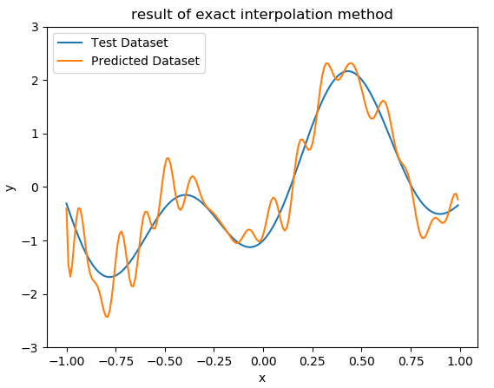

Figure 1. the result of the exact interpolation method

Figure 1 shows the test dataset output and predicted output. The predicted output does not fit well on the test dataset output. The average error rate is 0.649. The result implies that there exists overfitting along the approximation performance. This is due to the added noise is learned by the RBFN model during the training period. Therefore, this model is very sensitive to noise.

**b). Fixed Centers Selected at Random**

1. **import** numpy as np
2. **import** matplotlib.pyplot as plt
3. **import** random
5. x_train = np.arange(-1,1,0.05)
6. y_train = 1.2*np.sin(np.pi*x_train) - np.cos(2.4*np.pi*x_train)
8. x_test = np.arange(-1,1,0.01)
9. y_test = 1.2*np.sin(np.pi*x_test) - np.cos(2.4*np.pi*x_test)
11. np.random.seed(6)
12. g_noise = np.random.normal(0,1,y_train.shape[0])
13. y_train_n = y_train + 0.3*g_noise
15. x_centers = []
16. y_centers = []
17. M = 15
18. # Select random 15 data points
19. idx = random.sample(range(0,len(x_train)),M)
21. **for** i **in** range(len(idx)):
22. x_centers.append(x_train[idx[i]])
23. # y_centers.append(y_train_n[idx[i]])
25. d_max = max(x_centers) - min(x_centers)
26. sigma = d_max/np.sqrt(2*M)
28. **def** guassian(r):
29. **return** np.exp(-r**2/(2*sigma**2))
31. **def** phi_matrix(x,mu):
32. N = x.shape[0]
33. M = len(mu)
34. phi = np.zeros((N,M))
35. **for** i **in** range(N):
36. **for** j **in** range(M):
37. r = x[i]-mu[j]
38. phi[i][j] = guassian(r)
39. **return** phi
41. **def** weights(mu,x,d):
42. phi = phi_matrix(x,mu)
43. **return** np.linalg.inv(np.dot(phi.T,phi)).dot(phi.T).dot(d)
45. **def** predict(x_train,x_test,weights):
46. y_pre = []
47. **for** j **in** range(x_test.shape[0]):
48. y = 0
49. **for** i **in** range(len(x_train)):
50. r = x_test[j] - x_train[i]
51. y += weights[i]*guassian(r)
52. y_pre.append(y)
53. **return** y_pre
55. w = weights(x_centers,x_train,y_train_n)
56. pre_test = predict(x_centers,x_test,w)
57. mean_error = np.mean(abs((pre_test - y_test)/y_test))
58. **print**(mean_error)
60. plt.figure()
61. plt.plot(x_test,y_test,x_test,pre_test)
62. plt.legend(('Test Output', 'Predicted Output'))
63. plt.title('result of fixed centres selected at random method')
64. plt.ylim(-3, 3)
65. plt.xlabel('x')
66. plt.ylabel('y')
67. plt.show()

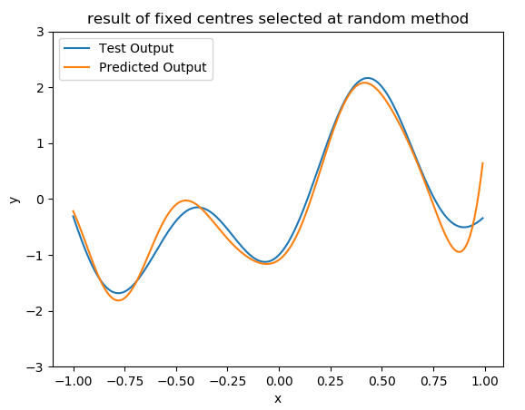

Figure 2. result of fixed centres selected at random method

Figure 2 shows the result of the RBFN using fixed centres selected at random method, with 15 randomly selected centres. The average error rate is 0.4181. The output is quite smooth with less overfitting. The predicted approximation output of test dataset performs better than the result obtained in part a. Therefore, this method can help reduce the effect of noise.

**c) RBFN with regularization applied**

1. **import** numpy as np
2. **import** matplotlib.pyplot as plt
4. x_train = np.arange(-1,1,0.05)
5. y_train = 1.2*np.sin(np.pi*x_train) - np.cos(2.4*np.pi*x_train)
7. x_test = np.arange(-1,1,0.01)
8. y_test = 1.2*np.sin(np.pi*x_test) - np.cos(2.4*np.pi*x_test)
10. np.random.seed(2)
11. g_noise = np.random.normal(0,1,y_train.shape[0])
12. y_train_n = y_train + 0.3*g_noise
14. sigma = 0.1
15. lmd_set = [0.001, 0.005, 0.01, 0.05, 0.1, 0.5, 1, 3, 5, 10]
17. **def** guassian(r):
18. **return** np.exp(-r**2/(2*sigma**2))
20. **def** phi_matrix(x):
21. d = x.shape[0]
22. phi = np.zeros((d,d))
23. **for** i **in** range(d):
24. **for** j **in** range(d):
25. r = x[i]-x[j]
26. phi[i][j] = guassian(r)
27. **return** phi
29. **def** weights(x,d,lmd):
30. phi = phi_matrix(x)
31. I = np.identity(phi.shape[0])
32. **return** np.linalg.inv(np.dot(phi.T,phi) + lmd*I).dot(phi.T).dot(d)
34. **def** predict(x_train,x_test,weights):
35. y_pre = []
36. **for** j **in** range(x_test.shape[0]):
37. y = 0
38. **for** i **in** range(x_train.shape[0]):
39. r = x_test[j] - x_train[i]
40. y += weights[i]*guassian(r)
41. y_pre.append(y)
42. **return** y_pre
44. pre_test = []
45. **for** i **in** range(len(lmd_set)):
46. w = weights(x_train,y_train_n,lmd_set[i])
47. pre_test.append(predict(x_train,x_test,w))

50. plt.figure()
51. **for** i **in** list(range(0,9,2)):
52. plt.subplot(1,2,1)
53. plt.plot(x_test,y_test,color = 'red',label ='Test Output')
54. plt.plot(x_test,pre_test[i],color = 'blue',label ='Predicted Output')
55. plt.title('The result of the exact interpolation with regularization λ = '+ str(lmd_set[i]))
56. plt.ylim(-3,3)
57. plt.xlabel('x')
58. plt.ylabel('y')
59. plt.legend()
61. plt.subplot(1,2,2)
62. plt.plot(x_test,y_test,color = 'red',label ='Test Output')
63. plt.plot(x_test,pre_test[i+1],color = 'blue',label ='Predicted Output')
64. plt.title('The result of the exact interpolation with regularization λ = '+ str(lmd_set[i+1]))
65. plt.ylim(-3,3)
66. plt.xlabel('x')
67. plt.ylabel('y')
68. plt.legend()
69. plt.show()
70. plt.clf()
72. err_set = []
73. **for** i **in** range(len(lmd_set)):
74. err_set.append(np.mean(abs((pre_test[i] - y_test)/y_test)))
75. **print**(min(err_set))
76. plt.plot(lmd_set,err_set)
77. plt.xlabel('Regularization Factor')
78. plt.ylabel('Average Relative Error')
79. plt.title('Average Relative Error versus the Regularization Factor on Test Data Set')
80. plt.show()

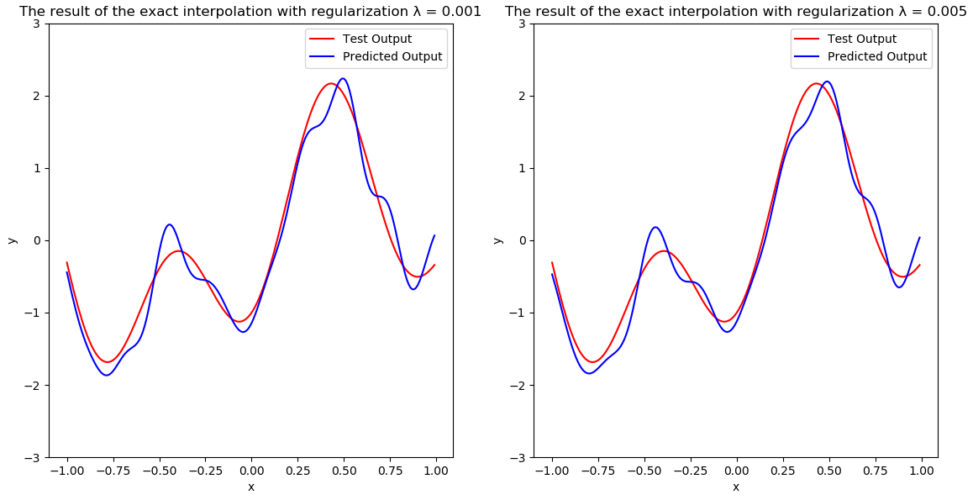

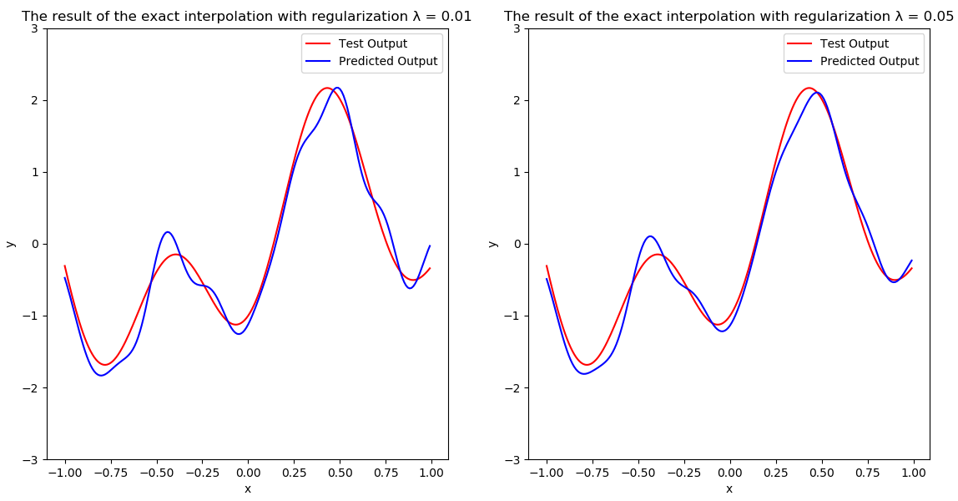

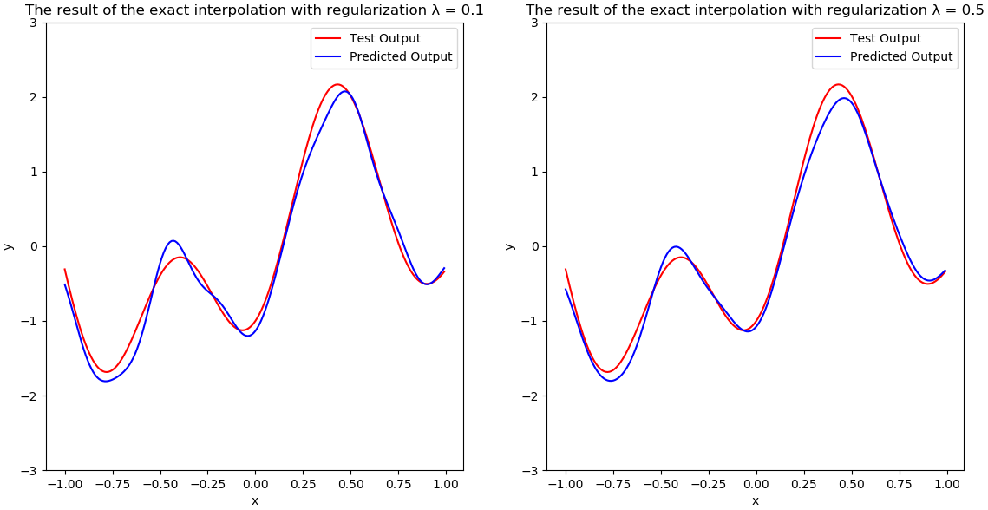

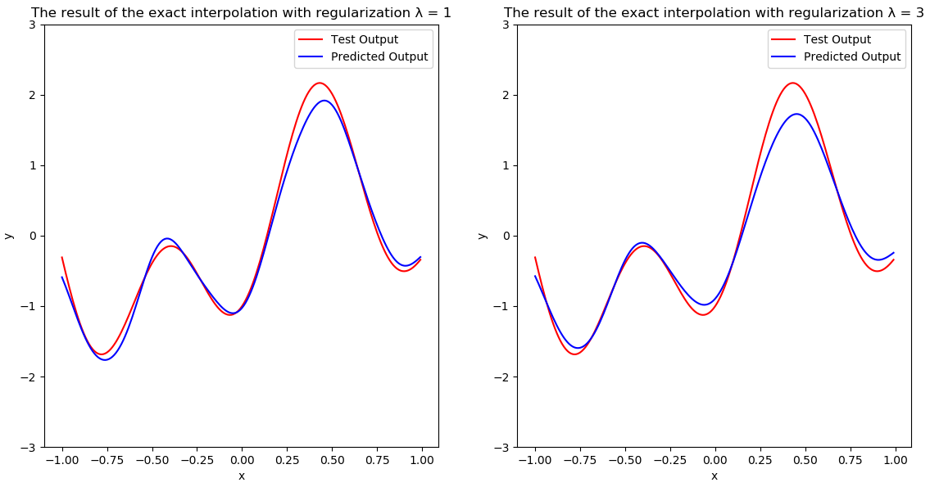

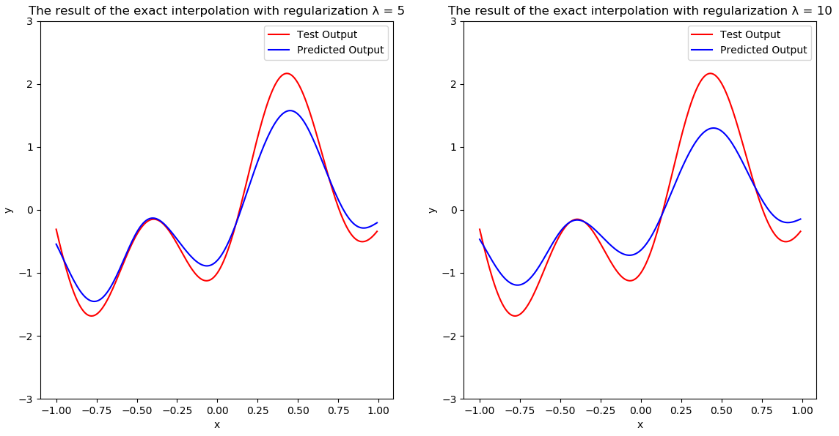

The figures above show the performance of RBFN in exact interpolation method with different λ values. And we can find that there is no severe overfitting along the output compare the result obtained in part a. Therefore, regularization help reduces variance. And from different values of λ, we can also find that the overfitting is reduced when λ increase from 0 to 1. And if keep increasing λ, the predicted output will be underfit. Thus, we need to tune the regularization factor λ to make the model achieve good performance.

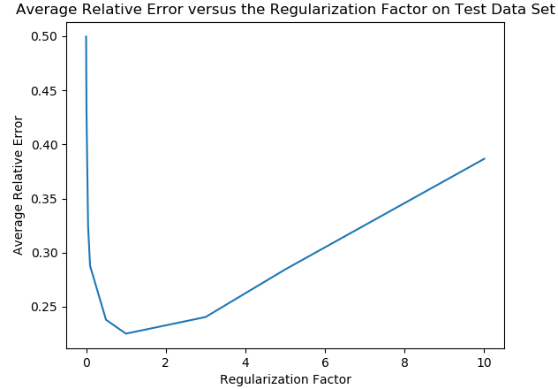

Figure 3. Average Relative Error vs the Regularization Factor on Test Data Set

The Figure 3 shows that when λ = 1, the model achieves the best result. And the average relative error is 0.225.

**Q2. Handwritten Digits Classification using RBFN**

My matric Number is A0117981X, mark digit 8 as class 1, mark digit 1 as class 0.

Source Code: in exact interpolation method without regularization

1. **import** numpy as np
2. **from** scipy **import** io
3. **import** matplotlib.pyplot as plt
5. # Load Data
6. mat = io.loadmat('../MNIST_database.mat')
7. x_train_raw = mat['train_data'].T           # shape (1000,784)
8. y_train_raw = mat['train_classlabel'].T     # shape (1000,1)
9. x_test_raw = mat['test_data'].T             # shape (250,784)
10. y_test_raw = mat['test_classlabel'].T       # shape (250,1)
11. # my matrix No. A0117981X, mark digit 8 class 1 and digit 1 as class 0
12. x_train = x_train_raw[np.where((y_train_raw ==8) | (y_train_raw ==1))[0]]
13. y_train = y_train_raw[np.where((y_train_raw ==8) | (y_train_raw ==1))[0]]
14. x_test = x_test_raw[np.where((y_test_raw ==8) | (y_test_raw ==1))[0]]
15. y_test = y_test_raw[np.where((y_test_raw ==8) | (y_test_raw ==1))[0]]
16. y_train = np.where(y_train == 8, 1,0)
17. y_test = np.where(y_test == 8, 1,0)
18. np.random.seed(8)
20. **def** guassian(r):
21. **return** np.exp(-r**2/(2*sigma**2))
23. **def** phi_matrix(x):
24. d = x.shape[0]
25. phi = np.zeros((d,d))
26. **for** i **in** range(d):
27. **for** j **in** range(d):
28. r = x[i]-x[j]
29. phi[i][j] = guassian(np.linalg.norm(r))
30. **return** phi
32. **def** weights(x,d):
33. phi = phi_matrix(x)
34. **return** np.linalg.inv(phi).dot(d)
36. **def** predict(x_train,x_test,W):
37. y_pre = np.zeros((x_test.shape[0], 1))
38. **for** j **in** range(x_test.shape[0]):
39. y = 0
40. **for** i **in** range(x_train.shape[0]):
41. r = x_test[j] - x_train[i]
42. y += W[i]*guassian(np.linalg.norm(r))
43. y_pre[j][0] = y
44. **return** y_pre
46. sigma = 100
47. w = weights(x_train,y_train)
48. pre_test = predict(x_train,x_test,w)
49. pre_train = predict(x_train,x_train,w)
51. TrAcc = []
52. TeAcc = []
53. TrN = y_train.shape[0]
54. TeN = y_test.shape[0]
55. Threshold = []
56. **for** i **in** range(1000):
57. t = (np.amax(pre_train) - np.amin(pre_train))*i/1000 + np.amin(pre_train)
58. Threshold.append(t)
59. TrAcc.append((np.sum(y_train[pre_train<t]==0) + np.sum(y_train[pre_train>=t]==1)) / TrN)
60. TeAcc.append((np.sum(y_test[pre_test<t]==0) + np.sum(y_test[pre_test>=t]==1)) / TeN)
62. plt.figure()
63. plt.plot(Threshold,TrAcc,Threshold,TeAcc)
64. plt.title('Accuracy in Exact Interpolation Method without regularization')
65. plt.legend(('Train ', 'Test'))
66. plt.xlabel('Threshold')
67. plt.ylabel('Accuracy')
68. plt.show()

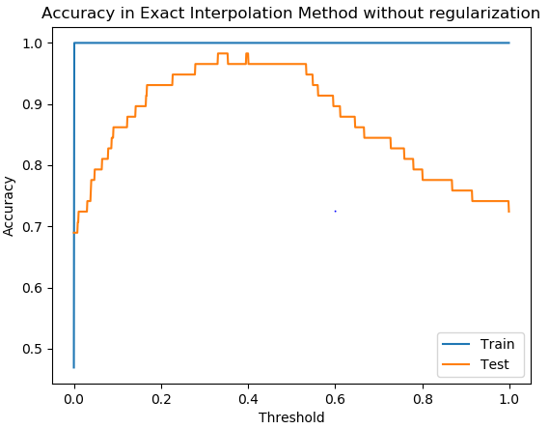

Figure 4. Accuracy vs Threshold in Exact Interpolation Method without regularization

The figure shows that the accuracy of training dataset jumps from 0 to 1 when threshold is above 0. And the accuracy of testing dataset starts from 0.68 when Threshold is 0, it keeps increasing to 0.97 when threshold is 0.3. Then it starts to decrease when threshold keeps increasing from 0.5.

Source Code: in exact interpolation method with regularization

1. **import** numpy as np
2. **from** scipy **import** io
3. **import** matplotlib.pyplot as plt
5. # Load Data
6. mat = io.loadmat('../MNIST_database.mat')
7. x_train_raw = mat['train_data'].T           # shape (1000,784)
8. y_train_raw = mat['train_classlabel'].T     # shape (1000,1)
9. x_test_raw = mat['test_data'].T             # shape (250,784)
10. y_test_raw = mat['test_classlabel'].T       # shape (250,1)
12. # my matrix No. A0117981X, mark digit 8 class 1 and digit 1 as class 0
13. x_train = x_train_raw[np.where((y_train_raw ==8) | (y_train_raw ==1))[0]]
14. y_train = y_train_raw[np.where((y_train_raw ==8) | (y_train_raw ==1))[0]]
15. x_test = x_test_raw[np.where((y_test_raw ==8) | (y_test_raw ==1))[0]]
16. y_test = y_test_raw[np.where((y_test_raw ==8) | (y_test_raw ==1))[0]]
18. y_train = np.where(y_train == 8, 1,0)
19. y_test = np.where(y_test == 8, 1,0)
21. np.random.seed(8)
22. sigma = 100
23. **def** guassian(r):
24. **return** np.exp(-r**2/(2*sigma**2))
26. **def** phi_matrix(x):
27. d = x.shape[0]
28. phi = np.zeros((d,d))
29. **for** i **in** range(d):
30. **for** j **in** range(d):
31. r = x[i]-x[j]
32. phi[i][j] = guassian(np.linalg.norm(r))
33. **return** phi
35. **def** weights(x,d,lmd):
36. phi = phi_matrix(x)
37. I = np.identity(phi.shape[0])
38. **return** np.linalg.inv(np.dot(phi.T,phi) + lmd*I).dot(phi.T).dot(d)
40. **def** predict(x_train,x_test,W):
41. y_pre = np.zeros((x_test.shape[0], 1))
42. **for** j **in** range(x_test.shape[0]):
43. y = 0
44. **for** i **in** range(x_train.shape[0]):
45. r = x_test[j] - x_train[i]
46. y += W[i]*guassian(np.linalg.norm(r))
47. y_pre[j][0] = y
48. **return** y_pre
50. lmd_set = [0,0.001,0.005,0.01,0.05,0.1,0.5,1,5,10]
51. pre_test = []
52. pre_train = []
53. **for** i **in** range(len(lmd_set)):
54. w = weights(x_train,y_train,lmd_set[i])
55. pre_train.append(predict(x_train,x_train,w))
56. pre_test.append(predict(x_train,x_test,w))
58. TrN = y_train.shape[0]
59. TeN = y_test.shape[0]
60. TrAccuracy = []
61. TeAccuracy = []
62. thr = []
63. **for** j **in** range(len(lmd_set)):
64. TrAcc = []
65. TeAcc = []
66. Threshold = []
67. **for** i **in** range(1000):
68. t = (np.amax(pre_train[j]) - np.amin(pre_train[j]))*i/1000 + np.amin(pre_train[j])
69. Threshold.append(t)
71. TrAcc.append((np.sum(y_train[pre_train[j]<t]==0) + np.sum(y_train[pre_train[j]>=t]==1)) / TrN)
72. TeAcc.append((np.sum(y_test[pre_test[j]<t]==0) + np.sum(y_test[pre_test[j]>=t]==1)) / TeN)
73. thr.append(Threshold)
74. TrAccuracy.append(TrAcc)
75. TeAccuracy.append(TeAcc)
77. plt.figure()
78. **for** i **in** list(range(0,9,2)):
79. plt.subplot(1,2,1)
80. plt.plot(thr[i],TrAccuracy[i],thr[i],TeAccuracy[i])
81. plt.title('Performance with regularization λ = '+str(lmd_set[i]))
82. plt.legend(('Train ', 'Test'))
83. plt.xlabel('Threshold')
84. plt.ylabel('Accuracy')
86. plt.subplot(1,2,2)
87. plt.plot(thr[i+1],TrAccuracy[i+1],thr[i+1],TeAccuracy[i+1])
88. plt.title('Performance with regularization λ = '+str(lmd_set[i+1]))
89. plt.legend(('Train', 'Test'))
90. plt.xlabel('Threshold')
91. plt.ylabel('Accuracy')
92. plt.show()
93. plt.clf()

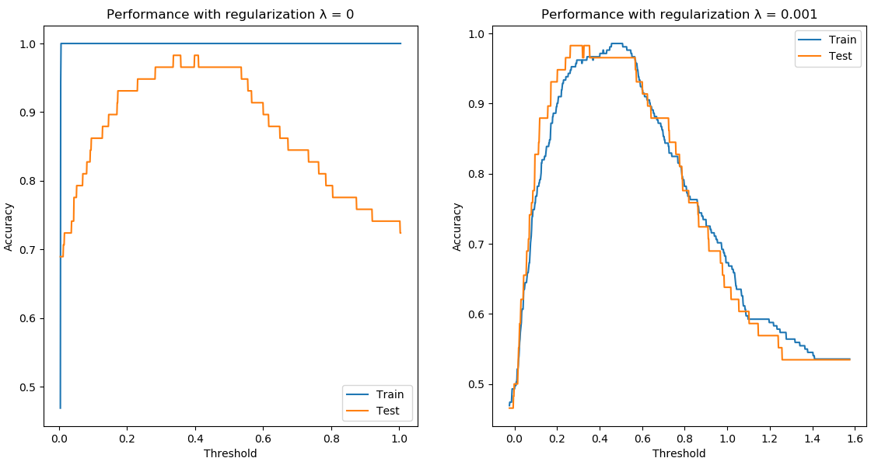

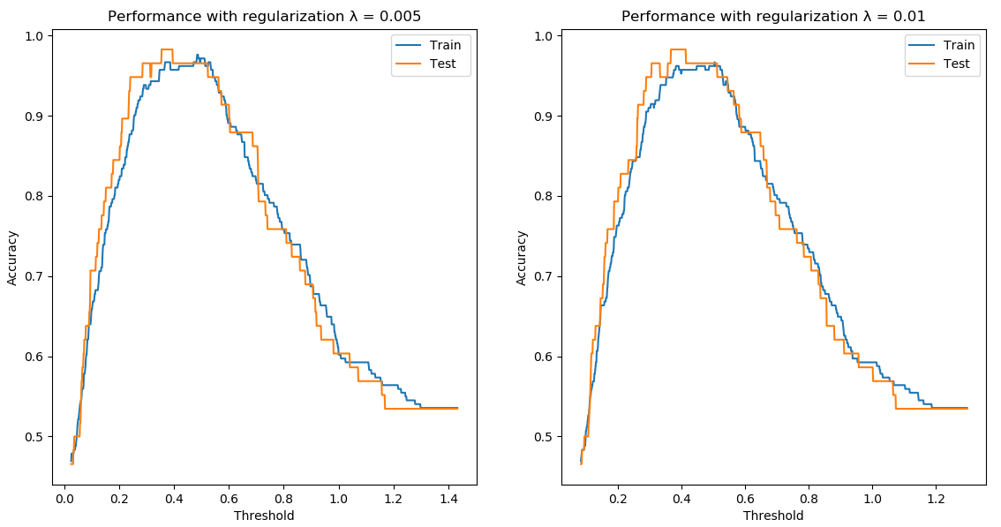

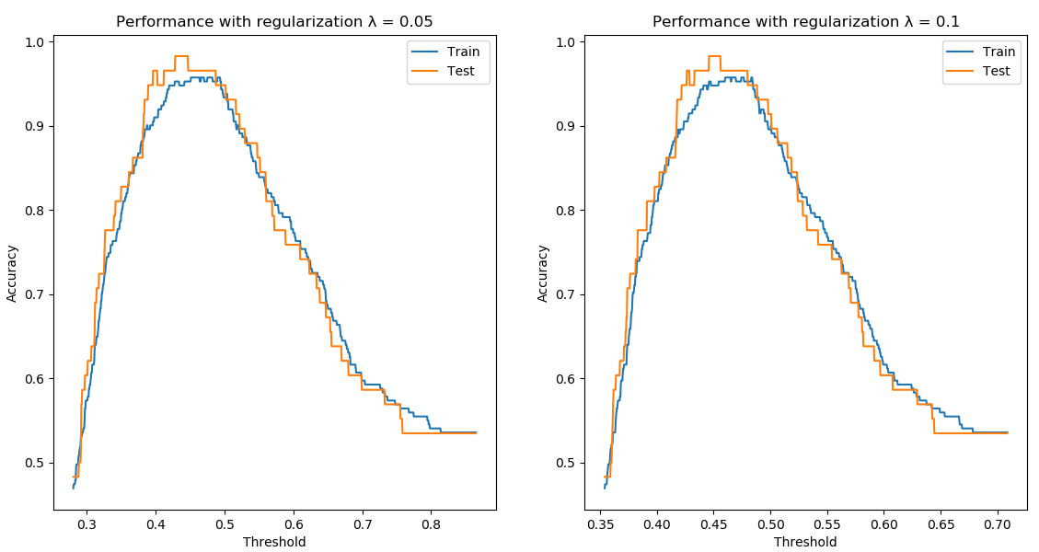

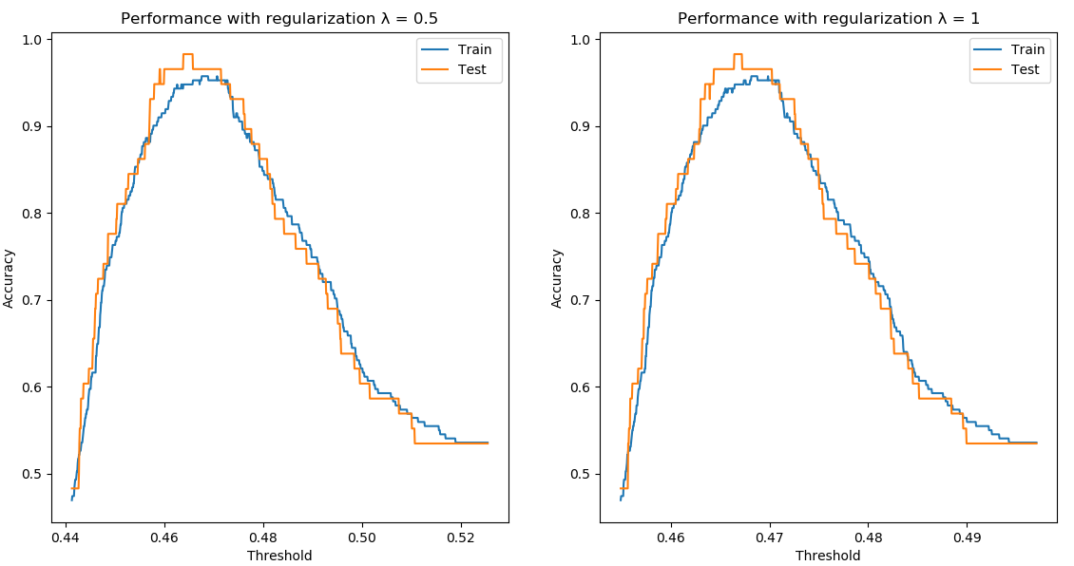

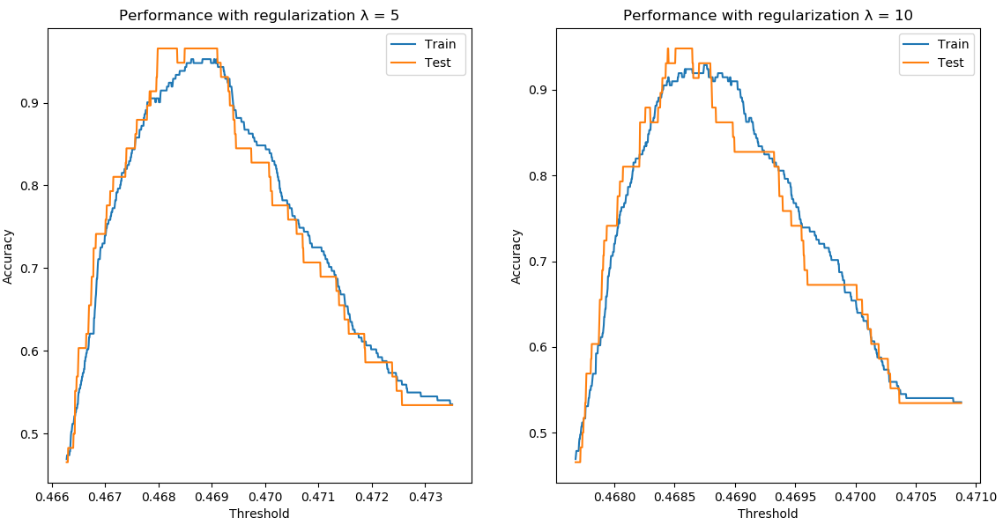

The Figures above show the performance of RBFN model with different regularization factors λ. When λ is 0, which means there is no regularization factor. And the result is almost the same as first part. As λ increases, the accuracies of training dataset and testing dataset increase similarly. The accuracy of testing set can reach maximum of 97% when the threshold value is about 0.45. And as λ keeps increase to a large value, both accuracies will degrade.

2b). **Apply Fixed Centers Selected at Random Method**

Source Code:

1. **import** numpy as np
2. **from** scipy **import** io
3. **import** matplotlib.pyplot as plt
4. **import** random
5. **from** scipy.spatial.distance **import** cdist
7. # Load Data
8. mat = io.loadmat('../MNIST_database.mat')
9. x_train_raw = mat['train_data'].T           # shape (1000,784)
10. y_train_raw = mat['train_classlabel'].T     # shape (1000,1)
11. x_test_raw = mat['test_data'].T             # shape (250,784)
12. y_test_raw = mat['test_classlabel'].T       # shape (250,1)
13. # my matrix No. A0117981X, mark digit 8 class 1 and digit 1 as class 0
14. x_train = x_train_raw[np.where((y_train_raw ==8) | (y_train_raw ==1))[0]]
15. y_train = y_train_raw[np.where((y_train_raw ==8) | (y_train_raw ==1))[0]]
16. x_test = x_test_raw[np.where((y_test_raw ==8) | (y_test_raw ==1))[0]]
17. y_test = y_test_raw[np.where((y_test_raw ==8) | (y_test_raw ==1))[0]]
18. y_train = np.where(y_train == 8, 1,0)
19. y_test = np.where(y_test == 8, 1,0)

22. # np.random.seed(8)
23. **def** guassian(r):
24. **return** np.exp(-r**2/(2*sigma**2))
26. **def** phi_matrix(x,centre):
27. N = x.shape[0]
28. M = centre.shape[0]
29. phi = np.zeros((N,M))
30. **for** i **in** range(N):
31. **for** j **in** range(M):
32. r = x[i]-centre[j]
33. phi[i][j] = guassian(np.linalg.norm(r))
34. **return** phi
36. **def** weights(x,d,centre):
37. phi = phi_matrix(x,centre)
38. **return** np.linalg.inv(np.dot(phi.T,phi)).dot(phi.T).dot(d)
40. **def** predict(centre,x_test,W):
41. y_pre = np.zeros((x_test.shape[0], 1))
42. **for** j **in** range(x_test.shape[0]):
43. y = 0
44. **for** i **in** range(centre.shape[0]):
45. r = x_test[j] - centre[i]
46. y += W[i]*guassian(np.linalg.norm(r))
47. y_pre[j][0] = y
48. **return** y_pre
50. M = 100
51. # Select random 100 data points
52. # np.random.seed(12)
53. idx = random.sample(range(0,len(x_train)),M)
54. centres = x_train[idx,:]
56. d = cdist(centres,centres,metric='euclidean')
57. d_max = np.amax(d)
58. sigma = d_max/np.sqrt(2*M)
59. **print**('The width is '+str(sigma))
61. w = weights(x_train,y_train,centres)
62. pre_test = predict(centres,x_test,w)
63. pre_train = predict(centres,x_train,w)

66. TrAcc = []
67. TeAcc = []
68. thr = []
69. TrN = y_train.shape[0]
70. TeN = y_test.shape[0]
71. Thr = []
72. **for** i **in** range(1000):
73. t = (np.amax(pre_train) - np.amin(pre_train))*i/1000 + np.amin(pre_train)
74. Thr.append(t)
76. TrAcc.append((np.sum(y_train[pre_train<t]==0) + np.sum(y_train[pre_train>=t]==1)) / TrN)
77. TeAcc.append((np.sum(y_test[pre_test<t]==0) + np.sum(y_test[pre_test>=t]==1)) / TeN)
79. plt.figure()
80. plt.plot(Thr,TrAcc,Thr,TeAcc)
81. plt.title('Fixed Centres Selected at Random with width at '+str(round(sigma,2)))
82. plt.legend(('Train ', 'Test'))
83. plt.xlabel('Threshold')
84. plt.ylabel('Accuracy')
85. plt.show()

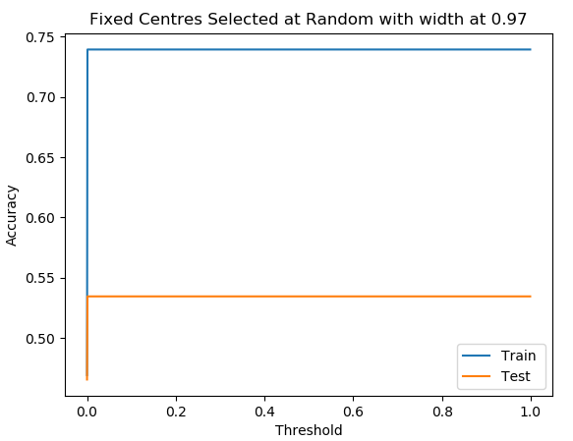

Figure 5. Performance of Fixed Centres Selected at Random with width

Figure 5. shows the Performance of Fixed Centres Selected with width. And the width is calculated as:

we can find that both training and testing set accuracies are not performing well and decision boundary is narrow. This is because the RBF is too peaked, this will squeeze the distribution of data points. Therefore, this leads to a hard decision boundary and degrade performance.

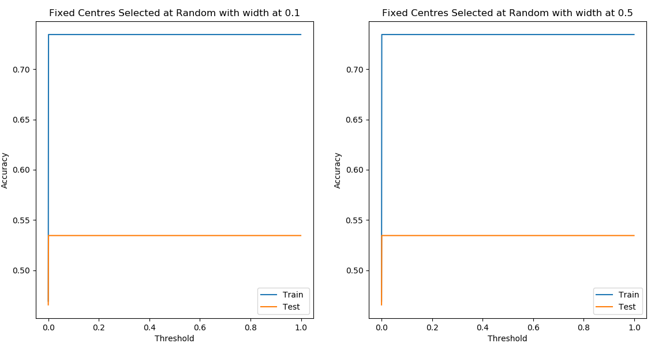

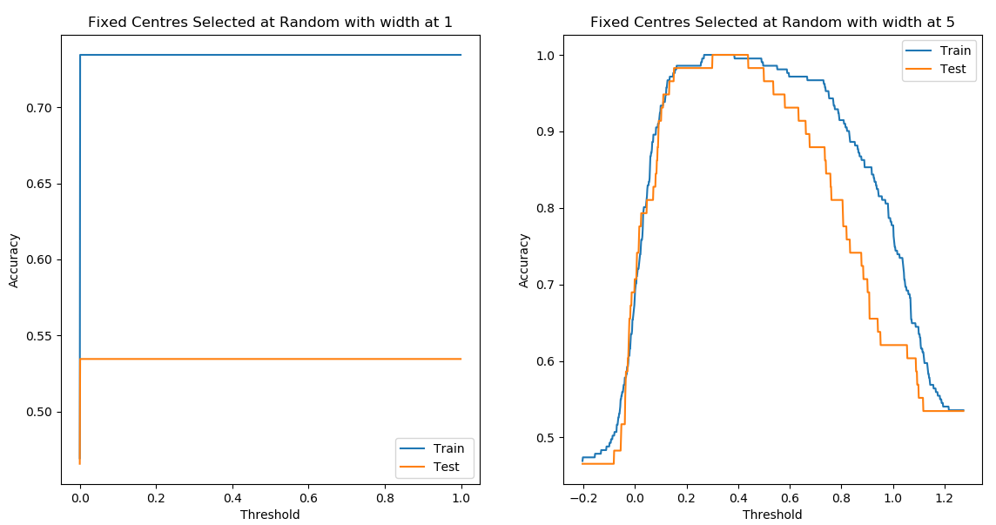

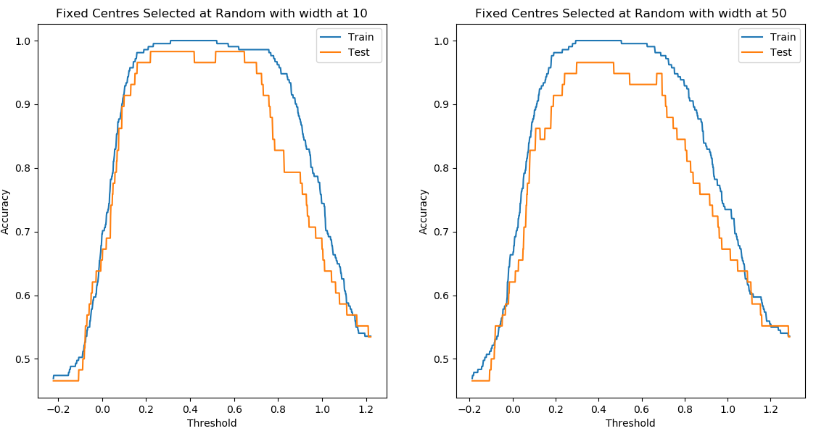

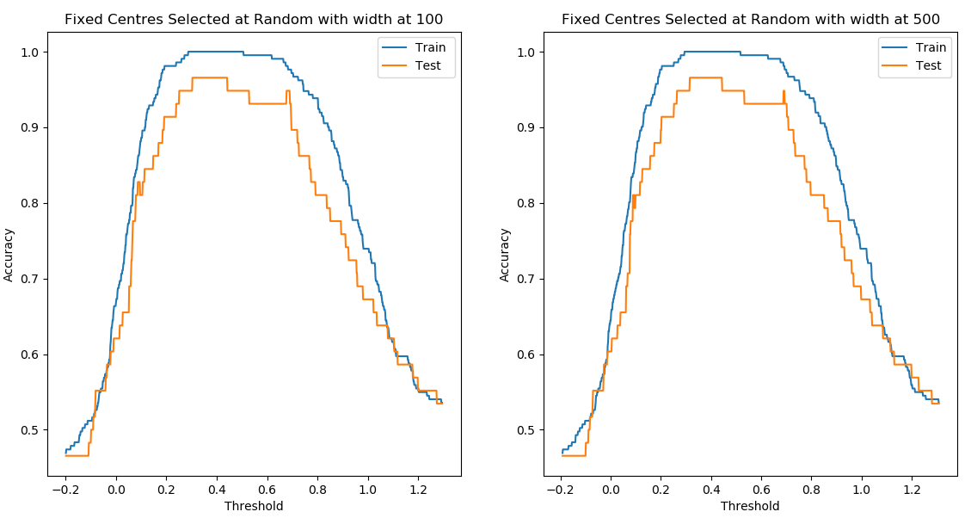

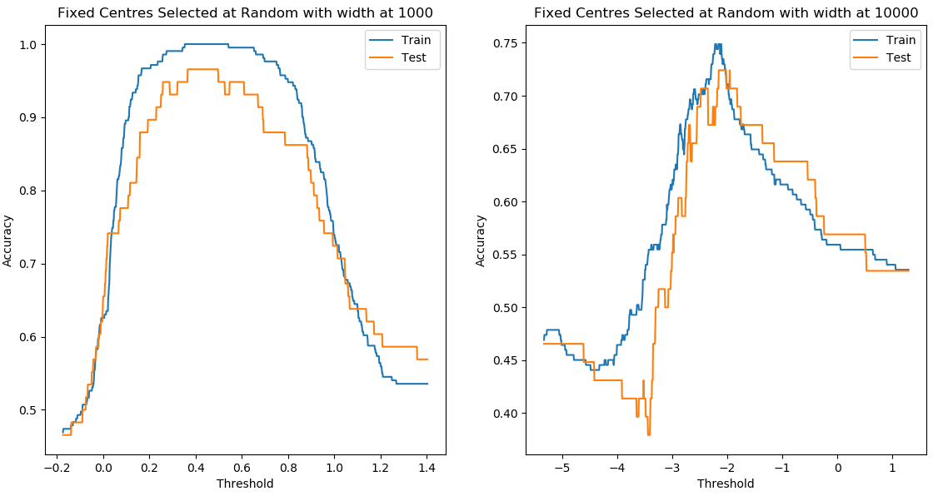

Source code: for different width set, other functions are same as above

1. M = 100
2. # Select random 100 data points
3. np.random.seed(8)
4. idx = random.sample(range(0,len(x_train)),M)
5. centres = x_train[idx,:]
7. d = cdist(centres,centres,metric='euclidean')
8. d_max = np.amax(d)
9. # sigma = d_max/np.sqrt(2*M)
11. sigma_set = [0.1,0.5,1,5,10,50,100,500,1000,10000]
12. pre_test = []
13. pre_train = []
14. **for** j **in** range(len(sigma_set)):
15. sigma = sigma_set[j]
16. w = weights(x_train,y_train,centres)
17. pre_test.append(predict(centres,x_test,w))
18. pre_train.append(predict(centres,x_train,w))

21. TrN = y_train.shape[0]
22. TeN = y_test.shape[0]
23. TrAccuracy = []
24. TeAccuracy = []
25. thr = []
27. **for** j **in** range(len(sigma_set)):
28. TrAcc = []
29. TeAcc = []
30. Threshold = []
31. **for** i **in** range(1000):
32. t = (np.amax(pre_train[j]) - np.amin(pre_train[j]))*i/1000 + np.amin(pre_train[j])
33. Threshold.append(t)
35. TrAcc.append((np.sum(y_train[pre_train[j]<t]==0) + np.sum(y_train[pre_train[j]>=t]==1)) / TrN)
36. TeAcc.append((np.sum(y_test[pre_test[j]<t]==0) + np.sum(y_test[pre_test[j]>=t]==1)) / TeN)
37. thr.append(Threshold)
38. TrAccuracy.append(TrAcc)
39. TeAccuracy.append(TeAcc)


43. plt.figure()
44. **for** i **in** list(range(0,9,2)):
45. plt.subplot(1,2,1)
46. plt.plot(thr[i],TrAccuracy[i],thr[i],TeAccuracy[i])
47. plt.title('Fixed Centres Selected at Random with width at '+str(round(sigma_set[i],2)))
48. plt.legend(('Train ', 'Test'))
49. plt.xlabel('Threshold')
50. plt.ylabel('Accuracy')
52. plt.subplot(1,2,2)
53. plt.plot(thr[i+1],TrAccuracy[i+1],thr[i+1],TeAccuracy[i+1])
54. plt.title('Fixed Centres Selected at Random with width at '+str(round(sigma_set[i+1],2)))
55. plt.legend(('Train', 'Test'))
56. plt.xlabel('Threshold')
57. plt.ylabel('Accuracy')
58. plt.show()
59. plt.clf()

The figures above show the performance RBFN model using Fixed Centres Selected at Random Method with different widths from 0.1 to 10000. We can see that both training and testing set accuracy increase and then decrease as width increases. The accuracy can achieve above 95% when width is from 5 to 1000. However, if width is too large, both training and testing accuracies are getting worse. Therefore, we need to tune the width to achieve good performance, which means we cannot select the width that is too small and too large.

**2c) Apply K- Mean Clustering with 2 centres**

Source code:

1. **import** numpy as np
2. **import** matplotlib.pyplot as plt
3. **import** random
4. **from** scipy **import** io
5. **from** scipy.spatial.distance **import** cdist
6. **from** sklearn.decomposition **import** PCA
8. # Load Data
9. mat = io.loadmat('../MNIST_database.mat')
10. x_train_raw = mat['train_data'].T           # shape (1000,784)
11. y_train_raw = mat['train_classlabel'].T     # shape (1000,1)
12. x_test_raw = mat['test_data'].T             # shape (250,784)
13. y_test_raw = mat['test_classlabel'].T       # shape (250,1)
14. # my matrix No. A0117981X, mark digit 8 class 1 and digit 1 as class 0
15. x_train = x_train_raw[np.where((y_train_raw ==8) | (y_train_raw ==1))[0]]
16. y_train = y_train_raw[np.where((y_train_raw ==8) | (y_train_raw ==1))[0]]
17. x_test = x_test_raw[np.where((y_test_raw ==8) | (y_test_raw ==1))[0]]
18. y_test = y_test_raw[np.where((y_test_raw ==8) | (y_test_raw ==1))[0]]
19. y_train = np.where(y_train == 8, 1,0)
20. y_test = np.where(y_test == 8, 1,0)
21. # np.random.seed(12)
22. **def** euclDistance(vector1,vector2):
23. **return** np.sqrt(np.sum(np.power(vector2 - vector1,2)))
25. **def** initCentroids(dataSet,k):
26. nuSamples, dim = dataSet.shape
27. index = random.sample(range(nuSamples),k) #randomly generate k non repeated num, return in list
28. # centroids = np.array([dataSet[i,:] for i in index]) # create k centroids from the array
29. centroids = x_train[np.random.randint(dataSet.shape[0], size=2), :] #random centres
30. **return** centroids
32. **def** k_means(dataSet,k):
33. nuSamples = dataSet.shape[0]
34. clusterAssment = np.zeros((nuSamples,2))
35. centroids = initCentroids(dataSet,k)
36. clusterChanged = True
37. **while** clusterChanged:
38. clusterChanged = False
39. **for** i **in** range(nuSamples):
40. minDistance = float("inf")
41. ownGroup = 0
42. **for** j **in** range(k):
43. distance = euclDistance(centroids[j,:],dataSet[i,:])
44. **if** distance < minDistance:
45. minDistance = distance
46. ownGroup = j
47. **if** clusterAssment[i,1] != ownGroup:
48. clusterAssment[i,1] = ownGroup
49. clusterChanged = True
50. **for** j **in** range(k):
51. pointsInCluster = dataSet[np.nonzero(clusterAssment[:,1]==j)[0]]
52. centroids[j,:] = np.mean(pointsInCluster,axis =0)
53. **return** centroids
55. k = 2
56. centroids = k_means(x_train, k)
58. d = cdist(centroids,centroids,metric='euclidean')
59. d_max = np.amax(d)
60. sigma = d_max/np.sqrt(2*k)
62. **def** guassian(r):
63. **return** np.exp(-r**2/(2*sigma**2))
65. **def** phi_matrix(x,centre):
66. N = x.shape[0]
67. M = centre.shape[0]
68. phi = np.zeros((N,M))
69. **for** i **in** range(N):
70. **for** j **in** range(M):
71. r = x[i]-centre[j]
72. phi[i][j] = guassian(np.linalg.norm(r))
73. **return** phi
75. **def** weights(x,d,centre):
76. phi = phi_matrix(x,centre)
77. **return** np.linalg.inv(np.dot(phi.T,phi)).dot(phi.T).dot(d)
79. **def** predict(centre,x,W):
80. y_pre = np.zeros((x.shape[0], 1))
81. **for** j **in** range(x.shape[0]):
82. y = 0
83. **for** i **in** range(centre.shape[0]):
84. r = x[j] - centre[i]
85. y += W[i]*guassian(np.linalg.norm(r))
86. y_pre[j][0] = y
87. **return** y_pre

90. w = weights(x_train,y_train,centroids)
91. pre_test = predict(centroids,x_test,w)
92. pre_train = predict(centroids,x_train,w)

95. TrAcc = []
96. TeAcc = []
97. thr = []
98. TrN = y_train.shape[0]
99. TeN = y_test.shape[0]
100. Thr = []
101. **for** i **in** range(1000):
102. t = (np.amax(pre_train) - np.amin(pre_train))*i/1000 + np.amin(pre_train)
103. Thr.append(t)
105. TrAcc.append((np.sum(y_train[pre_train<t]==0) + np.sum(y_train[pre_train>=t]==1)) / TrN)
106. TeAcc.append((np.sum(y_test[pre_test<t]==0) + np.sum(y_test[pre_test>=t]==1)) / TeN)
108. # accuracy
109. plt.figure()
110. plt.plot(Thr,TrAcc,Thr,TeAcc)
111. plt.title('Accuracy in K-Mean Clustering with 2 centres')
112. plt.legend(('Train ', 'Test'))
113. plt.xlabel('Threshold')
114. plt.ylabel('Accuracy')
115. plt.show()
116. plt.clf()

119. mean_value = np.zeros((2,784))
120. **for** i **in** range(k):
121. mean_value[i,:] = np.mean(x_train[np.nonzero(y_train[:,0]==i)[0]],axis =0)

124. # dimension reduction
125. pca = PCA(2)
126. projected = pca.fit_transform(centroids)
127. classmean = pca.fit_transform(mean_value)
129. plt.scatter(projected[0:,0],projected[0:,1],s=400,c='red',marker='o',alpha=0.5,label='Centre A')
130. plt.scatter(classmean[1:,0],classmean[1:,1],s=400,c='black',marker='o',alpha=0.5,label='Class 0 mean')
132. plt.scatter(projected[1:,0],projected[1:,1],s=400,c='blue',marker='o',alpha=0.5,label='Centre B')
134. plt.scatter(classmean[0:,0],classmean[0:,1],s=400,c='green',marker='o',alpha=0.5,label='Class 1 mean')

137. plt.xlabel('component 1')
138. plt.ylabel('component 2')
139. plt.legend(prop = {'size':16})
140. plt.show()
141. plt.clf()

144. plt.subplot(2,2,1)
145. plt.imshow(centroids[0].reshape(28,28).T,cmap='gray')
146. plt.title('Centre A')
147. plt.axis('off')
149. plt.subplot(2,2,2)
150. plt.imshow(centroids[1].reshape(28,28).T,cmap='gray')
151. plt.title('Centre B')
152. plt.axis('off')
154. plt.subplot(2,2,3)
155. plt.imshow(mean_value[1].reshape(28,28).T,cmap='gray')
156. plt.title('Class 1 mean')
157. plt.axis('off')
159. plt.subplot(2,2,4)
160. plt.imshow(mean_value[0].reshape(28,28).T,cmap='gray')
161. plt.title('Class 0 mean')
162. plt.axis('off')
163. plt.show()

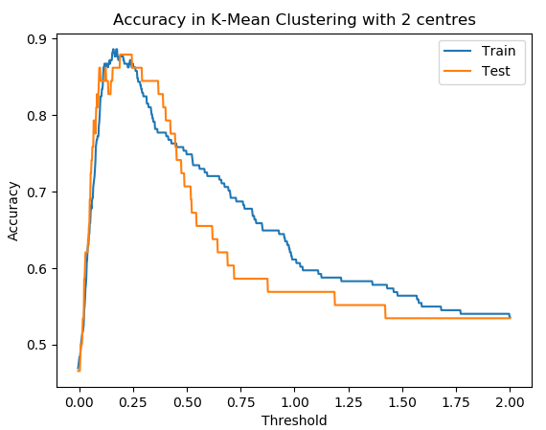

Figure 6. Performance of RBFN in K-Mean Clustering with 2 centres

Figure 6 shows the accuracy on both training set and testing set, and both accuracies can reach around 88%. Moreover, K-Mean Clustering compute faster as only two centres are selected.

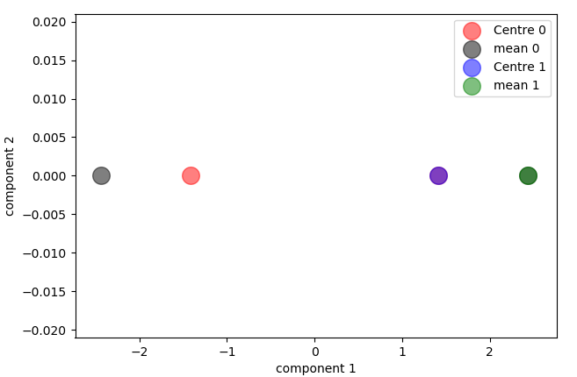

Figure 7. Clustering Centres and Class Mean Centres

Figure 7 shows the Clustering Centres and Class Mean Centres through PCA dimension reduction method in 2 Dimension.

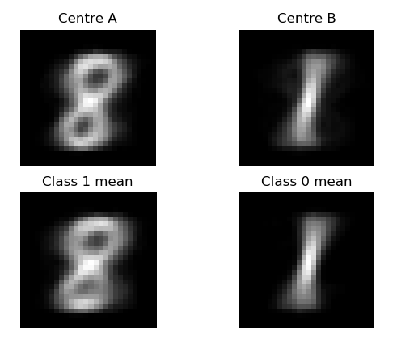

Figure 8. Visualization of obtained centres and mean centres

Figure 8 shows the images of obtained centres and mean centres. Centre A is similar to Class 1 mean, Centre B is similar to Class 0 mean. We can find that the visualization of the obtained centres and the mean of training images of each class are almost the same. In the k-mean clustering, the centres keep updated as the mean centre of each class. The iteration stops when members of the two classes are not changing anymore. That’s why the projected centre images and mean centres images are almost the same.

**Q3 Self-Organizing Map (SOM)**

a.) maps a 1-dimensional output layer of 25 neurons to a “heart curve”

1. **import** numpy as np
2. **import** random
3. **from** scipy.spatial.distance **import** cdist
4. **import** matplotlib.pyplot as plt
6. np.random.seed(6)
7. **def** initOutputLayer(m,n):  # m-number of neurons, n-dimension of feature
8. layer = np.random.rand(m,n)
9. **return** layer
11. # find min dist and return winer
12. **def** winnerIndex(x,y):
13. a = np.array(x).reshape(1,y.shape[1])
14. d = cdist(a,y,metric='euclidean')
15. idx = np.argmin(d)
16. **return** idx
18. **def** adjustWeight(layer,x,iter):
19. time_ew = iter /np.log(sigma_init)
20. w = layer
21. **for** i **in** range(iteration):
22. **for** j **in** range(x.shape[0]):
23. #winner index
24. idx = winnerIndex(x[j],w)
25. # update learning rate
26. LR = learn_rate*np.exp(-(i+1)/iter)
27. # update effective width
28. sigma = sigma_init*np.exp(-(i+1)/time_ew)
30. # time varying neibourhood func
31. N_index = np.arange(m).reshape(m,1)
32. h = np.exp(-(N_index - idx)**2/(2*sigma**2))
33. alpha = LR*h
34. # update weights
35. w = (1-alpha)*w + alpha*x[j]
36. **return** w

39. m = 25
40. n = 2
41. learn_rate = 0.1
42. iteration = 1000
43. sigma_init = 1 * m
44. t = np.linspace(-np.pi,np.pi,200)
46. trainX = np.array((t*np.sin(np.pi*np.sin(t)/t),1-abs(t)*np.cos(np.pi*np.sin(t)/t))).T
48. weights = adjustWeight(initOutputLayer(25,2),trainX,iteration)

51. plt.plot(trainX[:,0],trainX[:,1],)
52. plt.plot(weights[:,0],weights[:,1])
53. plt.title('Performance of SOM')
54. plt.legend(('Samples', 'Weights'))
55. plt.show()

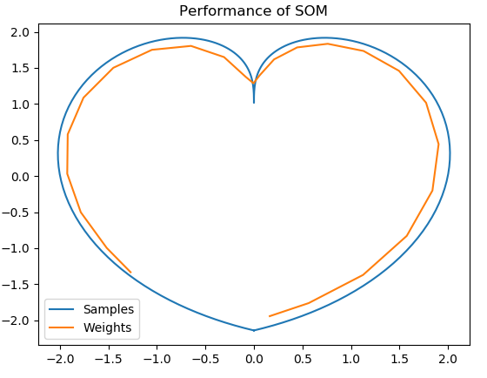

Figure 3-a-1 SOM Mapping for Heart Curve function

Figure 3-a-1 shows the SOM Mapping for Heart Curve function, and we can see that most of the weights fit to the desired output.

b) **a SOM that maps a 2-dimensional output layer of 25 neurons to a “square”**

Source code in Python:

1. **import** numpy as np
2. **import** random
3. **from** scipy.spatial.distance **import** cdist
4. **import** matplotlib.pyplot as plt
5. np.random.seed(12)
7. **def** init_grid(h,w):
8. k = 0
9. grid = np.zeros((h*w,2))
10. **for** i **in** range(h):
11. **for** j **in** range(w):
12. grid[k,:] = [i,j]
13. k += 1
14. **return** grid
16. **def** init_weights(h,w,n):  # m-number of neurons, n-dimension of feature
17. weights = np.random.rand(h*w,n)
18. **return** weights
20. # find min dist and return winer
21. **def** winnerIndex(x,y):
22. a = np.array(x).reshape(1,y.shape[1])
23. d = cdist(a,y,metric='euclidean')
24. idx = np.argmin(d)
25. **return** idx
27. **def** distEclud(x, weights):
28. dist = []
29. **for** w **in** weights:
30. d = np.linalg.norm(x-w)
31. dist.append(d)
32. **return** np.array(dist)
34. **def** adjustWeight(w,x,iter):
35. time_ew = iter /np.log(sigma_init)
37. **for** i **in** range(iteration):
38. **for** j **in** range(x.shape[0]):
39. # winner index
40. idx = winnerIndex(x[j],w)
41. a = np.array(grid[idx]).reshape(1,grid.shape[1])
42. d = cdist(a,grid,metric='euclidean')
44. # index2 = (dist2 ; 1).nonzero()[0]
45. # update learning rate
46. LR = learn_rate*np.exp(-(i+1)/iter)
47. # update effective width
48. sigma = sigma_init*np.exp(-(i+1)/time_ew)
50. # time varying neibourhood func
51. h1 = np.exp(-(d**2)/(2*sigma**2)).reshape(25,1)
52. alpha = LR*h1
53. # update weights
54. w = (1-alpha)*w + alpha*x[j]
55. **return** w
57. w = 5
58. h = 5
59. m = w*h
60. n = 2
61. learn_rate = 0.1
62. iteration = 1000
63. sigma_init = np.sqrt(w**2+h**2)/2
64. grid = init_grid(h,w)
65. weights = init_weights(h,w,n)
67. trainX = -1 + 2*np.random.random((500,2))
68. w = adjustWeight(weights,trainX,iteration)

71. **def** plot_weights(weights, h=5, w=5, size=(6,6)):
72. x_axis = weights[:,0].reshape(h, w)
73. y_axis = weights[:,1].reshape(h, w)
74. plt.figure(figsize=size)
75. plt.title('Training Points and Weights')
76. plt.scatter(trainX[:,0],trainX[:,1],c='blue',label = 'Samples')
77. plt.scatter(weights[:,0],weights[:,1],marker = 'x',c='red',label = 'Weights')
78. plt.legend(loc ='upper right')
79. **for** i **in** range(h):
80. plt.plot(x_axis[i], y_axis[i],c='red')
81. plt.plot(x_axis.T[i], y_axis.T[i],c='red')
82. plt.show()
84. plot_weights(w,5,5,size=(6,6))

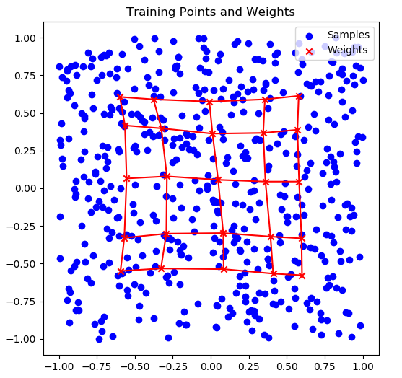

Figure 3-b-1 SOM square mapping

c-1) **Implement Cluster and Classify Handwritten Characters**

My Metrix Number is A0117981X. I ignore class 8 and 1.

Source Code in Python:

1. **import** numpy as np
2. **import** random
3. **from** scipy.spatial.distance **import** cdist
4. **import** matplotlib.pyplot as plt
5. **from** scipy **import** io
7. # np.random.seed(12)
8. # Load Data
9. mat = io.loadmat('../MNIST_database.mat')
10. x_train = mat['train_data'].T           # shape (1000,784)
11. y_train = mat['train_classlabel'].T     # shape (1000,1)
12. x_test = mat['test_data'].T             # shape (250,784)
13. y_test = mat['test_classlabel'].T       # shape (250,1)
15. # mark labels accordingly, my matrix No. A0117981X, mask digits 8 and 1
16. x_train = x_train[np.where((y_train !=8) & (y_train !=1))[0]]
18. **def** init_grid(h,w):
19. k = 0
20. grid = np.zeros((h*w,2))
21. **for** i **in** range(h):
22. **for** j **in** range(w):
23. grid[k,:] = [i,j]
24. k += 1
25. **return** grid
27. **def** init_weights(h,w,n):  # m-number of neurons, n-dimension of feature
28. weights = np.random.rand(h*w,n)
29. **return** weights
31. # find min dist and return winer
32. **def** winnerIndex(x,y):
33. a = np.array(x).reshape(1,y.shape[1])
34. d = cdist(a,y,metric='euclidean')
35. idx = np.argmin(d)
36. **return** idx
38. **def** adjustWeight(w,x,iter):
39. time_ew = iter /np.log(sigma_init)
41. **for** i **in** range(iteration):
42. **for** j **in** range(x.shape[0]):
43. # winner index
44. idx = winnerIndex(x[j],w)
45. a = np.array(grid[idx]).reshape(1,grid.shape[1])
46. d = cdist(a,grid,metric='euclidean')
48. # update learning rate
49. LR = learn_rate*np.exp(-(i+1)/iter)
50. # update effective width
51. sigma = sigma_init*np.exp(-(i+1)/time_ew)
53. # time varying neibourhood func
55. h1 = np.exp(-(d**2)/(2*sigma**2)).reshape(100,1)
56. alpha = LR*h1
57. # update weights
58. w = (1-alpha)*w + alpha*x[j]
59. **return** w

62. w = 10
63. h = 10
64. m = w*h
65. n = 28*28
66. learn_rate = 0.1
67. iteration = 10
68. sigma_init = np.sqrt(w**2+h**2)/2
69. grid = init_grid(h,w)
70. weights = init_weights(h,w,n)
72. updated_w = adjustWeight(weights,x_train,iteration)
74. #conceptual
75. plt.figure()
76. **for** i **in** range(100):
77. index = winnerIndex(updated_w[i],x_train)
78. plt.subplot(10,10,i+1)
79. plt.imshow(x_train[index].reshape(28,28).T,cmap='gray')
80. plt.axis('off')
81. plt.show()
83. ##Visualization of Weight
84. plt.figure()
85. **for** j **in** range(100):
87. plt.subplot(10,10,j+1)
88. plt.imshow(updated_w[j].reshape(28,28).T,cmap='gray')
89. plt.axis('off')
90. plt.show()

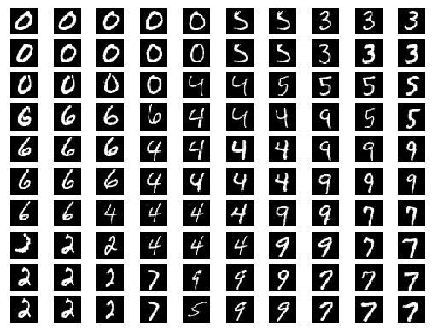

Figure 3-c-1 Conceptual/Semantic Map

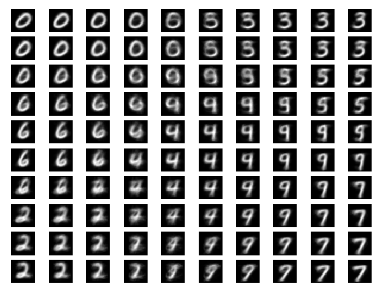

Figure 3-c-2 Visualization of weights

Figure 3-c-1 shows corresponding conceptual/semantic map of the trained SOM. and Figure 3-c-2 shows the trained weights of each output neuron on a 10×10 map. Compare these two figures, we can find that the images are matched on the same on the same position. This is because the conceptual/semantic map consists of winner input images corresponding to each weight.

**c-2) Classification accuracy**

Source Code in Python:

1. **import** numpy as np
2. **import** random
3. **from** scipy.spatial.distance **import** cdist
4. **import** matplotlib.pyplot as plt
5. **from** scipy **import** io

8. # Load Data
9. mat = io.loadmat('../MNIST_database.mat')
10. x_train = mat['train_data'].T           # shape (1000,784)
11. y_train = mat['train_classlabel'].T     # shape (1000,1)
12. x_test = mat['test_data'].T             # shape (250,784)
13. y_test = mat['test_classlabel'].T       # shape (250,1)
15. # mark labels accordingly, my matrix No. A0117981X, mask digits 8 and 1
16. idx_train = np.where((y_train != 8) & (y_train != 1))[0]
17. idx_test = np.where((y_test !=8) & (y_test !=1))[0]
18. y_train = y_train[idx_train]
19. x_train = x_train[idx_train]
21. x_test = x_test[idx_test]
22. y_test = y_test[idx_test]
24. x_test = x_test[np.where((y_test !=8) & (y_test !=1))[0]]
26. **def** init_grid(h,w):
27. k = 0
28. grid = np.zeros((h*w,2))
29. **for** i **in** range(h):
30. **for** j **in** range(w):
31. grid[k,:] = [i,j]
32. k += 1
33. **return** grid
35. np.random.seed(6)
36. **def** init_weights(h,w,n):  # m-number of neurons, n-dimension of feature
37. weights = np.random.rand(h*w,n)
38. **return** weights
40. # find min dist and return winer
41. **def** winnerIndex(x,y):
42. a = np.array(x).reshape(1,y.shape[1])
43. d = cdist(a,y,metric='euclidean')
44. idx = np.argmin(d)
45. **return** idx
47. **def** adjustWeight(w,x,iter):
48. time_ew = iter /np.log(sigma_init)
49. **for** i **in** range(iteration):
50. **for** j **in** range(x.shape[0]):
51. # winner index
52. idx = winnerIndex(x[j],w)
53. a = np.array(grid[idx]).reshape(1,grid.shape[1])
54. d = cdist(a,grid,metric='euclidean')
56. # update learning rate
57. LR = learn_rate*np.exp(-(i+1)/iter)
58. # update effective width
59. sigma = sigma_init*np.exp(-(i+1)/time_ew)
61. # time varying neibourhood func
62. h1 = np.exp(-(d**2)/(2*sigma**2)).reshape(100,1)
63. alpha = LR*h1
64. # update weights
65. w = (1-alpha)*w + alpha*x[j]
66. **return** w
68. w = 10
69. h = 10
70. m = w*h
71. n = 28*28
72. learn_rate = 0.1
73. iteration = 10
74. sigma_init = np.sqrt(w**2+h**2)/2
75. grid = init_grid(h,w)
76. weights = init_weights(h,w,n)
77. updated_w = adjustWeight(weights,x_train,iteration)

80. W_labels = []
81. **for** i **in** range(100):
82. index = winnerIndex(updated_w[i],x_train)
83. W_labels.append(y_train[index][0])
85. test_Labels =[]
86. **for** j **in** range(x_test.shape[0]):
87. index = winnerIndex(x_test[j],updated_w)
88. test_Labels.append(W_labels[index])
90. error =0
91. **for** k **in** range(x_test.shape[0]):
92. **if** test_Labels[k] != y_test[k][0]:
93. error +=1
94. # print(error)
95. acc = 1-error/x_test.shape[0]
96. **print**('The classification accuracy of testing set is %.2f' %(acc*100) +'%')

The final classification accuracy is 75% after 100 epochs of training which is slightly lower than the results obtained in RBFN model. This is because that some images may be assigned to their adjacent class groups since they have similar features.